International Seminar on Therapeutic Riding
(For acquisition of the Diploma for Therapeutic Riding Instructors)

The three-level International Seminar is organized by the Hellenic Association for Therapeutic Riding (ELETHIP, GR), the Pennsylvania Council on Therapeutic Horsemanship (PACTH, USA) and the Federation of Horses in Education and Therapy International (HETI).

The seminar curriculum is specific regardless of the country where the seminar is held and the certification examinations (for Level II and Level III) are of the same format and content in all countries.
The attendance certification as well as the final Diploma for Therapeutic Riding Instructors acquired upon completion of the seminar is internationally recognized.

Information on the seminar has already been posted on the website of the Federation of Horses in Education and Therapy International www.frdi.net, in the International Calendar section.

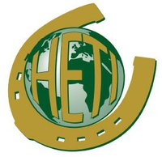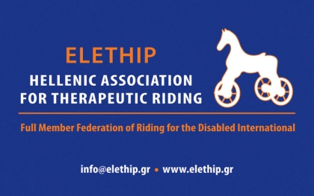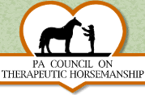

LEVEL I

Date: January 3rd until January 6th, 2014 (4 days, 09:00 – 18:00)

Location: Athens, at a Riding Club collaborating with ELETHIP.

Instructors:

- Prof. Ann O’Shallie (USA), President of the Federation of Horses in Education and Therapy International (HETI), Therapeutic Riding professor at the Wilson College, Master of Science in Equine & Animal Science, Level III Instructor & Examiner.
- Gisela H.Rhodes (USA, GER), Executive director of the Federation of Horses in Education and Therapy International (HETI), Master of Arts in Education, Interactive Vaulting Instructor, Level III Instructor and Examiner.
- Irene Kapari (GR), NDT Physical Therapist, specialized on Hippotherapy, Therapeutic Riding Instructor, Assistant Examiner, National Classifier, Head of the Hellenic Association for Therapeutic Riding.
- Eleni Matsouki (GR), MDT Physical Therapist, specialized on Therapeutic Riding and Hippotherapy, Organizational Head of the Hellenic Association for Therapeutic Riding.

Attendance requirements: Being 18 years of age or older and having or intending to acquire basic equestrian knowledge within the next two years.

Language: English

The seminar includes a theoretical part and a laboratory part. It does not include the administration of examinations.
Attendees will receive notes and materials for the Level I seminar as well as a Certificate of Attendance.
Sportswear is required (track suites, trainers, riding clothes, etc.)
There will be two upcoming seminars (Levels II & III), which will include examinations (written, oral and lesson demonstration)
All three levels are expected to be completed by January 2015.

Seminar cost:
For registration before the 6th of December, 2013: 300 Euros (25% discount over the initial fee).
After the aforementioned date and until the first day of the seminar, the fee will be 400 Euros.
In order for your registration to be valid, the fees will need to be deposited to the bank account number you will receive upon completion and submission of your participation application.
(In the case of not meeting the required number of attendees – 15 people – the seminar will be postponed and the fees will be refunded.)

Accommodation:
Those participants who require accommodation at a hotel near the location of the seminar will need to state so on their application and we will inform them on the nearby hotels where they will be able to direct their inquiries.

Contact/Information:
Irene Kapari, tel.: 0030 6977 20 11 86 (office hours), email - irenekapari@hotmail.com
www.elethip.gr

facebook - Ελληνική Εταιρία Θεραπευτικής Ιππασίας, Hellenic Association for Therapeutic Riding

